|  |
| --- |
|  |
|  |
| *Manual testing* |
|  |
|  |
| **Stanciu Alin-Georgian** |
|  |

**Trainer**: **Dorha Alex**

**INTRODUCTION**

https://demo.prestashop.com/

The website used for manual testing is a demo website that has various functionalities which can be tested. The website subject is an store which has clothes, accesories and art store.

The manual testing in this project includes “Register” and “Login” pages, “My account” page and “Cart” page with “Checkout” page.

As a client using this website, we should be able to register, login, modify informations in our account, choose what products we want to buy, add them to cart and checkout them. For this, we need to follow some steps in our manual testing.

|  |  |
| --- | --- |
| 1 | Registration |
| 2 | Logging in |
| 3 | Modifying “My account” details. |
| 4 | Product page |
| 5 | Proceeding to checkout |

1. 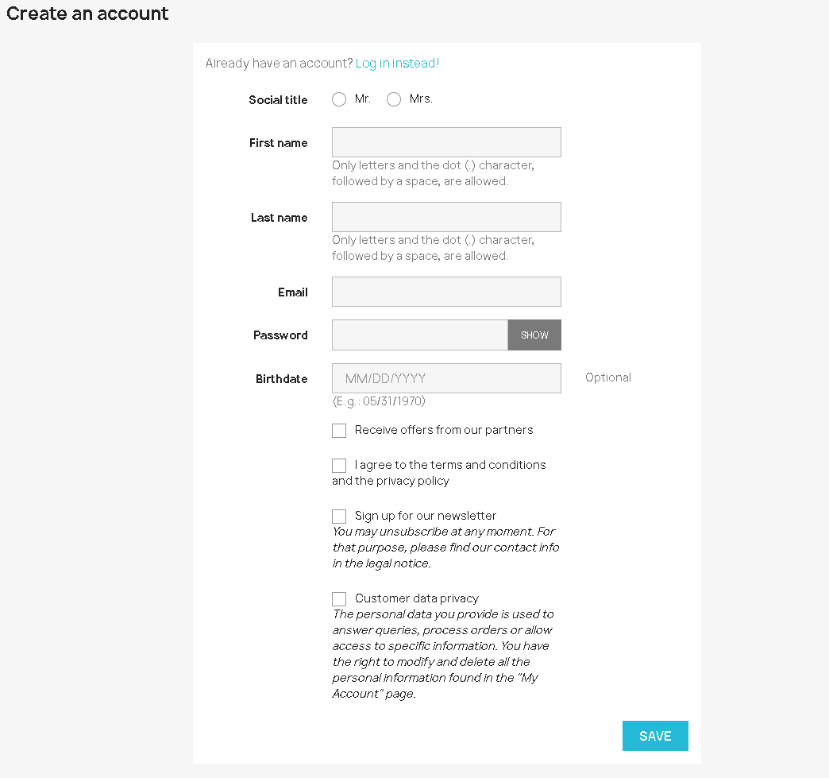**Registration**

|  |  |  |
| --- | --- | --- |
| Test case 1 | **TITLE** | Register page |
| **PRECONDITIONS** | A browser is displayed  URL “https://tired-mass.demo.prestashop.com/en/” was accesed |
| **STEPS** | The user clicks on “Create account” button in bottom of the page |
| **EXPECTED RESULT** | A new page with the name "Create account" will be displayed  Register form will be displayed and contains:  - Social title  - First name  - Last name  - Email  - Password  - Birthdate  - 4 checkboxes |

|  |  |  |  |
| --- | --- | --- | --- |
| Test case 2 | **TITLE** | | Registration process with valid values for all the fields |
| **PRECONDITIONS** | | Sign up page was displayed |
| **STEPS** | | The user enters valid values for all the mandatory fields  The user clicks on “Save” button |
| **EXPECTED RESULT** | | The account will be created. And the main page will be displayed with user logged in his account. |
|  |  | |  |
| Test case 3 | **TITLE** | | Registration process with invalid values for all the fields |
| **PRECONDITIONS** | | Sign up page was displayed |
| **STEPS** | | The user enters invalid values for all the mandatory fields  The user clicks on “Save” button |
| **EXPECTED RESULT** | | The account is not created.  Error message will be displayed: “Please fill out this field.” |
|  | |  |  |
| Test case 4 | | **TITLE** | Registration process with valid value only for first name |
| **PRECONDITIONS** | Sign up page was displayed |
| **STEPS** | The user enters valid value for first name only  The user clicks on “Save” button |
| **EXPECTED RESULT** | The account is not created. Error message will be displayed: “Please fill out this field” in last name field. |
|  | |  |  |
| Test case 5 | | **TITLE** | Registration process with valid value only for last name |
| **PRECONDITIONS** | Sign up page was displayed |
| **STEPS** | The user enters valid value for last name only  The user clicks on “Save” button |
| **EXPECTED RESULT** | The account is not created. Error message will be displayed: “Please fill out this field” in first name field. |
|  | |  |  |
| Test case 6 | | **TITLE** | Registration process with valid value only for email |
| **PRECONDITIONS** | Sign up page was displayed |
| **STEPS** | The user enters valid value for email only  The user clicks on “Save” button |
| **EXPECTED RESULT** | The account is not created. Error message will be displayed: “Please fill out this field” in first name field. |
|  | |  |  |
| Test case 7 | | **TITLE** | Registration process with valid value only for password |
| **PRECONDITIONS** | Sign up page was displayed |
| **STEPS** | The user enters valid value for password only  The user clicks on “Save” button |
| **EXPECTED RESULT** | The account is not created. Error message will be displayed: “Please fill out this field” in first name field. |
|  | |  |  |
| Test case 8 | | **TITLE** | Registration process with valid value only for first name and last name |
| **PRECONDITIONS** | Sign up page was displayed |
| **STEPS** | The user enters valid value for first name and last name only  The user clicks on “Save” button |
| **EXPECTED RESULT** | The account is not created. Error message will be displayed: “Please fill out this field” in email field. |
|  | |  |  |
| Test case 9 | | **TITLE** | Registration process with valid value only for first name and email |
| **PRECONDITIONS** | Sign up page was displayed |
| **STEPS** | The user enters valid value for first name and email only  The user clicks on “Save” button |
| **EXPECTED RESULT** | The account is not created. Error message will be displayed: “Please fill out this field” in last name field. |
|  | |  |  |
| Test case 10 | | **TITLE** | Registration process with valid value only for first name and password |
| **PRECONDITIONS** | Sign up page was displayed |
| **STEPS** | The user enters valid value for first name and password only  The user clicks on “Save” button |
| **EXPECTED RESULT** | The account is not created. Error message will be displayed: “Please fill out this field” in last name field. |
|  | |  |  |
| Test case 11 | | **TITLE** | Registration process with valid value only for first name and first mandatory checkbox |
| **PRECONDITIONS** | Sign up page was displayed |
| **STEPS** | The user enters valid value for first name only and checks the first mandatory checkbox  The user clicks on “Save” button |
| **EXPECTED RESULT** | The account is not created. Error message will be displayed: “Please fill out this field” in last name field. |
|  | |  |  |
| Test case 12 | | **TITLE** | Registration process with valid value only for first name and second mandatory checkbox |
| **PRECONDITIONS** | Sign up page was displayed |
| **STEPS** | The user enters valid value for first name only and checks the second mandatory checkbox  The user clicks on “Save” button |
| **EXPECTED RESULT** | The account is not created. Error message will be displayed: “Please fill out this field” in last name field. |
|  | |  |  |
| Test case 13 | | **TITLE** | Registration process with valid value only for first name and both mandatory checkbox |
| **PRECONDITIONS** | Sign up page was displayed |
| **STEPS** | The user enters valid value for first name only and checks both mandatory checkboxes.  The user clicks on “Save” button |
| **EXPECTED RESULT** | The account is not created. Error message will be displayed: “Please fill out this field” in last name field. |
|  | |  |  |
| Test case 14 | | **TITLE** | Registration process with valid value only for last name and email |
| **PRECONDITIONS** | Sign up page was displayed |
| **STEPS** | The user enters valid value for last name and email only  The user clicks on “Save” button |
| **EXPECTED RESULT** | The account is not created. Error message will be displayed: “Please fill out this field” in first name field. |
|  | |  |  |
| Test case 15 | | **TITLE** | Registration process with valid value only for last name and password |
| **PRECONDITIONS** | Sign up page was displayed |
| **STEPS** | The user enters valid value for last name and password only  The user clicks on “Save” button |
| **EXPECTED RESULT** | The account is not created. Error message will be displayed: “Please fill out this field” in first name field. |
|  | |  |  |
| Test case 16 | | **TITLE** | Registration process with valid value only for last name and first mandatory checkbox |
| **PRECONDITIONS** | Sign up page was displayed |
| **STEPS** | The user enters valid value for last name and password only and checks the first mandatory checkbox  The user clicks on “Save” button |
| **EXPECTED RESULT** | The account is not created. Error message will be displayed: “Please fill out this field” in first name field. |
|  | |  |  |
| Test case 17 | | **TITLE** | Registration process with valid value only for last name and second mandatory checkbox |
| **PRECONDITIONS** | Sign up page was displayed |
| **STEPS** | The user enters valid value for last name and password only and checks the second mandatory checkbox  The user clicks on “Save” button |
| **EXPECTED RESULT** | The account is not created. Error message will be displayed: “Please fill out this field” in first name field. |
|  | |  |  |
| Test case 18 | | **TITLE** | Registration process with valid value only for last name and both mandatory checkboxes |
| **PRECONDITIONS** | Sign up page was displayed |
| **STEPS** | The user enters valid value for last name and password only and checks both mandatory checkboxes  The user clicks on “Save” button |
| **EXPECTED RESULT** | The account is not created. Error message will be displayed: “Please fill out this field” in first name field. |
|  | |  |  |
| Test case 19 | | **TITLE** | Registration process with valid value only for email and password |
| **PRECONDITIONS** | Sign up page was displayed |
| **STEPS** | The user enters valid value for email and password only  The user clicks on “Save” button |
| **EXPECTED RESULT** | The account is not created. Error message will be displayed: “Please fill out this field” in first name field. |
|  | |  |  |
| Test case 20 | | **TITLE** | Registration process with valid value only email and first mandatory checkbox |
| **PRECONDITIONS** | Sign up page was displayed |
| **STEPS** | The user enters valid value for email only and checks the first mandatory checkbox  The user clicks on “Save” button |
| **EXPECTED RESULT** | The account is not created. Error message will be displayed: “Please fill out this field” in first name field. |
|  | |  |  |
| Test case 21 | | **TITLE** | Registration process with valid value only for email and second mandatory checkbox |
| **PRECONDITIONS** | Sign up page was displayed |
| **STEPS** | The user enters valid value for email only and checks the second mandatory checkbox  The user clicks on “Save” button |
| **EXPECTED RESULT** | The account is not created. Error message will be displayed: “Please fill out this field” in first name field. |
|  | |  |  |
| Test case 22 | | **TITLE** | Registration process with valid value only for email and both mandatory checkboxes |
| **PRECONDITIONS** | Sign up page was displayed |
| **STEPS** | The user enters valid value for email only and checks both mandatory checkboxes  The user clicks on “Save” button |
| **EXPECTED RESULT** | The account is not created. Error message will be displayed: “Please fill out this field” in first name field. |
|  | |  |  |
| Test case 23 | | **TITLE** | Registration process with valid value password only and first mandatory checkbox |
| **PRECONDITIONS** | Sign up page was displayed |
| **STEPS** | The user enters valid value for password only and checks only the first mandatory checkbox  The user clicks on “Save” button |
| **EXPECTED RESULT** | The account is not created. Error message will be displayed: “Please fill out this field” in first name field. |
|  | |  |  |
| Test case 24 | | **TITLE** | Registration process with valid value password only and second mandatory checkbox |
| **PRECONDITIONS** | Sign up page was displayed |
| **STEPS** | The user enters valid value for password only and checks only the second mandatory checkbox  The user clicks on “Save” button |
| **EXPECTED RESULT** | The account is not created. Error message will be displayed: “Please fill out this field” in first name field. |
|  | |  |  |
| Test case 25 | | **TITLE** | Registration process with valid value password only and both mandatory checkboxes |
| **PRECONDITIONS** | Sign up page was displayed |
| **STEPS** | The user enters valid value for password only and checks both mandatory checkboxes  The user clicks on “Save” button |
| **EXPECTED RESULT** | The account is not created. Error message will be displayed: “Please fill out this field” in first name field. |
|  | |  |  |
| Test case 26 | | **TITLE** | Registration process with invalid values and checked first mandatory checkbox |
| **PRECONDITIONS** | Sign up page was displayed |
| **STEPS** | The user enters invalid values for password only and checks only the first mandatory checkbox  The user clicks on “Save” button |
| **EXPECTED RESULT** | The account is not created. Error message will be displayed: “Please fill out this field” in first name field. |
|  | |  |  |
| Test case 27 | | **TITLE** | Registration process with invalid values and checked second mandatory checkbox |
| **PRECONDITIONS** | Sign up page was displayed |
| **STEPS** | The user enters invalid values for all fields but checks only the second checkbox  The user clicks on “Save” button |
| **EXPECTED RESULT** | The account is not created. Error message will be displayed: “Please fill out this field” in first name field. |
|  | |  |  |
| Test case 28 | | **TITLE** | Registration process with invalid values and checked both mandatory checkboxes |
| **PRECONDITIONS** | Sign up page was displayed |
| **STEPS** | The user enters invalid values for all mandatory fields, but checks both mandatory checkboxes  The user clicks on “Save” button |
| **EXPECTED RESULT** | The account is not created. Error message will be displayed: “Please fill out this field” in first name field |
|  | |  |  |
| Test case 29 | | **TITLE** | Register process with empty fields |
| **PRECONDITIONS** | Sign up page was displayed |
| **STEPS** | The user clicks on “Save” button |
| **EXPECTED RESULT** | The user is not logged in. Error message will be displayed: “Please fill out this field” in first name field |

1. 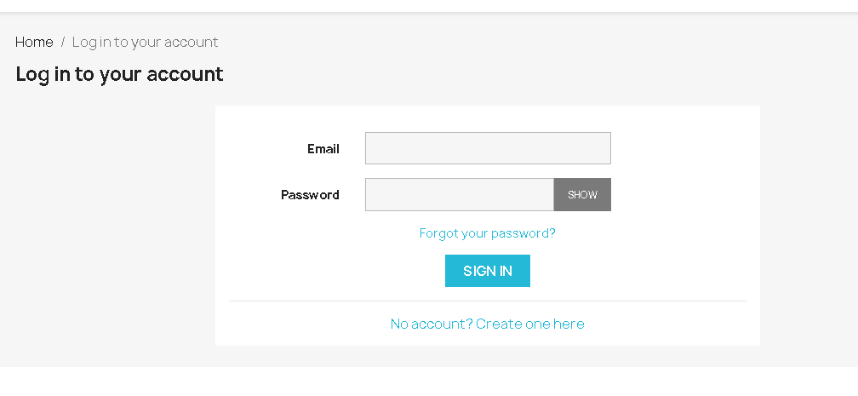**Logging into account**

|  |  |  |
| --- | --- | --- |
| Test case 1 | **TITLE** | Login process with valid values for all fields |
| **PRECONDITIONS** | A browser is displayed  URL <https://tired-mass.demo.prestashop.com/en/> was accesed |
| **STEPS** | The user clicks on “Sign in” from top page |
| **EXPECTED RESULT** | A new page with the name "Log in to your account" will be displayed  Login form will be displayed and contains:  - Email  - Password |

|  |  |  |
| --- | --- | --- |
|  |  |  |
| Test case 2 | **TITLE** | Login process with valid values for all fields |
| **PRECONDITIONS** | Login page was displayed |
| **STEPS** | The user fills with valid values both mandatory fields  The user clicks on “Sign in” button |
| **EXPECTED RESULT** | The user gets logged in his account and main page is displayed |
|  |  |  |
| Test case 3 | **TITLE** | Login process with invalid values for all fields |
| **PRECONDITIONS** | Login page was displayed |
| **STEPS** | The user fills with invalid values both mandatory fields  The user clicks on “Sign in” button |
| **EXPECTED RESULT** | The user does not gets logged in, and an "Authentication failed.” error appears |
|  |  |  |
| Test case 4 | **TITLE** | Login process with valid value for email only |
| **PRECONDITIONS** | Login page was displayed |
| **STEPS** | The user fills with valid value only email field  The user clicks on “Sign in” button |
| **EXPECTED RESULT** | The user is not logged in. Error message will be displayed: “Please fill out this field” in password field |
|  |  |  |
| Test case 5 | **TITLE** | Login process with valid value for password only |
| **PRECONDITIONS** | Login page was displayed |
| **STEPS** | The user fills with valid value only password field  The user clicks on “Sign in” button |
| **EXPECTED RESULT** | The user is not logged in. Error message will be displayed: “Please fill out this field” in email field |
|  |  |  |
| Test case 6 | **TITLE** | Login process with empty fields |
| **PRECONDITIONS** | Login page was displayed |
| **STEPS** | The user clicks on “Sign in” button |
| **EXPECTED RESULT** | The user is not logged in. Error message will be displayed: “Please fill out this field” in email field |
|  |  |  |
| Test case 7 | **TITLE** | Login process with valid value for email field and invalid value for password field |
| **PRECONDITIONS** | Login page was displayed |
| **STEPS** | The user fills with valid value for email field and invalid value for password field  The user clicks on “Sign in” button |
| **EXPECTED RESULT** | The user is not logged in. Error message will be displayed: “Please fill out this field” in password field |
|  |  |  |
| Test case 8 | **TITLE** | Login process with valid value for password field and invalid value for email field |
| **PRECONDITIONS** | Login page was displayed |
| **STEPS** | The user fills with valid value for password field and invalid value for email field  The user clicks on “Sign in” button |
| **EXPECTED RESULT** | The user is not logged in. Error message will be displayed: “Please fill out this field” in email field |

1. 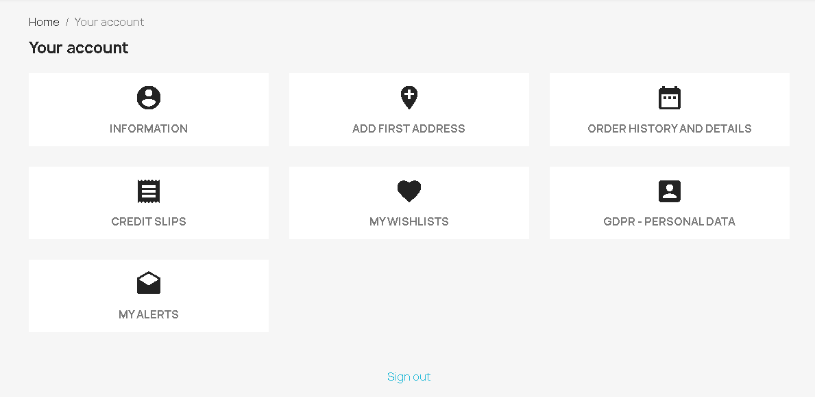**Modifying “My account” details.**
   1. 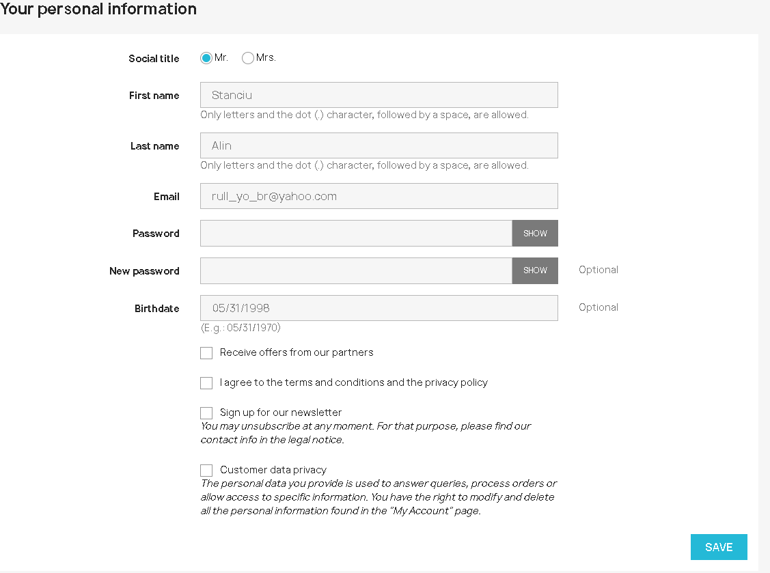**Information**

|  |  |  |
| --- | --- | --- |
| Test case 1 | **TITLE** | Updating information with empty fields |
| **PRECONDITIONS** | The user is logged in his account  The “personal information” page is displayed |
| **STEPS** | The user changes the social title to “Mrs.” (Mr. being default)  The user clicks on “Save” button |
| **EXPECTED RESULT** | The information will not be updated. Error message “Please fill out this field.” will be displayed in first name field |
|  |  |  |
| Test case 2 | **TITLE** | Updating information with valid values for all fields |
| **PRECONDITIONS** | The user is logged in his account  The “personal information” page is displayed |
| **STEPS** | The user changes the social title to “Mrs.” (Mr. being default)  The user fills with valid values all mandatory fields  The user clicks on “Save” button |
| **EXPECTED RESULT** | The information will be updated. A message “Information succesfully updated” is displayed. |
|  |  |  |
| Test case 3 | **TITLE** | Updating information with valid value only for first name |
| **PRECONDITIONS** | The user is logged in his account  The “personal information” page is displayed |
| **STEPS** | The user changes the social title to “Mrs.” (Mr. being default)  The user fills with valid value first name field  The user clicks on “Save” button |
| **EXPECTED RESULT** | The information will not be updated. Error message “Please fill out this field.” will be displayed in last name field |
|  |  |  |
| Test case 4 | **TITLE** | Updating information with valid value only for last name |
| **PRECONDITIONS** | The user is logged in his account  The “personal information” page is displayed |
| **STEPS** | The user changes the social title to “Mrs.” (Mr. being default)  The user fills with valid value last name field  The user clicks on “Save” button |
| **EXPECTED RESULT** | The information will not be updated. Error message “Please fill out this field.” will be displayed in first name field |
|  |  |  |
| Test case 5 | **TITLE** | Updating information with valid value only for email |
| **PRECONDITIONS** | The user is logged in his account  The “personal information” page is displayed |
| **STEPS** | The user changes the social title to “Mrs.” (Mr. being default)  The user fills with valid value email field  The user clicks on “Save” button |
| **EXPECTED RESULT** | The information will not be updated. Error message “Please fill out this field.” will be displayed in first name field |
|  |  |  |
| Test case 6 | **TITLE** | Updating information with valid value only for password |
| **PRECONDITIONS** | The user is logged in his account  The “personal information” page is displayed |
| **STEPS** | The user changes the social title to “Mrs.” (Mr. being default)  The user fills with valid value password field  The user clicks on “Save” button |
| **EXPECTED RESULT** | The information will not be updated. Error message “Please fill out this field.” will be displayed in first name field |
|  |  |  |
| Test case 7 | **TITLE** | Updating information with first checkbox only |
| **PRECONDITIONS** | The user is logged in his account  The “personal information” page is displayed |
| **STEPS** | The user changes the social title to “Mrs.” (Mr. being default)  The user tick first checkbox  The user clicks on “Save” button |
| **EXPECTED RESULT** | The information will not be updated. Error message “Please fill out this field.” will be displayed in first name field |
|  |  |  |
| Test case 8 | **TITLE** | Updating information with second checkbox only |
| **PRECONDITIONS** | The user is logged in his account  The “personal information” page is displayed |
| **STEPS** | The user changes the social title to “Mrs.” (Mr. being default)  The user tick second checkbox  The user clicks on “Save” button |
| **EXPECTED RESULT** | The information will not be updated. Error message “Please fill out this field.” will be displayed in first name field |
|  |  |  |
| Test case 9 | **TITLE** | Updating information with both checkboxes only |
| **PRECONDITIONS** | The user is logged in his account  The “personal information” page is displayed |
| **STEPS** | The user changes the social title to “Mrs.” (Mr. being default)  The user ticks both checkboxes  The user clicks on “Save” button |
| **EXPECTED RESULT** | The information will not be updated. Error message “Please fill out this field.” will be displayed in first name field |
|
| Test case 10 | **TITLE** | Updating information with first name and last name only |
| **PRECONDITIONS** | The user is logged in his account  The “personal information” page is displayed |
| **STEPS** | The user changes the social title to “Mrs.” (Mr. being default)  The user fills with valid values first name and last name  The user clicks on “Save” button |
| **EXPECTED RESULT** | The information will not be updated. Error message “Please fill out this field.” will be displayed in emailfield |
|  |  |  |
| Test case 11 | **TITLE** | Updating information with first name and email only |
| **PRECONDITIONS** | The user is logged in his account  The “personal information” page is displayed |
| **STEPS** | The user changes the social title to “Mrs.” (Mr. being default)  The user fills with valid values first name and email  The user clicks on “Save” button |
| **EXPECTED RESULT** | The information will not be updated. Error message “Please fill out this field.” will be displayed in last name field |
|  |  |  |
| Test case 12 | **TITLE** | Updating information with first name and password |
| **PRECONDITIONS** | The user is logged in his account  The “personal information” page is displayed |
| **STEPS** | The user changes the social title to “Mrs.” (Mr. being default)  The user fills with valid values first name and password  The user clicks on “Save” button |
| **EXPECTED RESULT** | The information will not be updated. Error message “Please fill out this field.” will be displayed in last name field |
|  |  |  |
| Test case 13 | **TITLE** | Updating information with first name and first checkbox |
| **PRECONDITIONS** | The user is logged in his account  The “personal information” page is displayed |
| **STEPS** | The user changes the social title to “Mrs.” (Mr. being default)  The user fills with valid values first name and ticks first checkbox  The user clicks on “Save” button |
| **EXPECTED RESULT** | The information will not be updated. Error message “Please fill out this field.” will be displayed in last name field |
| Test case 14 | **TITLE** | Updating information with first name and second checkbox |
| **PRECONDITIONS** | The user is logged in his account  The “personal information” page is displayed |
| **STEPS** | The user changes the social title to “Mrs.” (Mr. being default)  The user fills with valid values first name and ticks second checkbox  The user clicks on “Save” button |
| **EXPECTED RESULT** | The information will not be updated. Error message “Please fill out this field.” will be displayed in last name field |
|  |  |  |
| Test case 15 | **TITLE** | Updating information with first name and both checkboxes |
| **PRECONDITIONS** | The user is logged in his account  The “personal information” page is displayed |
| **STEPS** | The user changes the social title to “Mrs.” (Mr. being default)  The user fills with valid values first name and ticks both checkboxes  The user clicks on “Save” button |
| **EXPECTED RESULT** | The information will not be updated. Error message “Please fill out this field.” will be displayed in last name field |
|  |  |  |
| Test case 16 | **TITLE** | Updating information with last name and first checkbox |
| **PRECONDITIONS** | The user is logged in his account  The “personal information” page is displayed |
| **STEPS** | The user changes the social title to “Mrs.” (Mr. being default)  The user fills with valid values last name and ticks first checkbox  The user clicks on “Save” button |
| **EXPECTED RESULT** | The information will not be updated. Error message “Please fill out this field.” will be displayed in first name field |
|  |  |  |
| Test case 17 | **TITLE** | Updating information with last name and second checkbox |
| **PRECONDITIONS** | The user is logged in his account  The “personal information” page is displayed |
| **STEPS** | The user changes the social title to “Mrs.” (Mr. being default)  The user fills with valid values last name and ticks second checkbox  The user clicks on “Save” button |
| **EXPECTED RESULT** | The information will not be updated. Error message “Please fill out this field.” will be displayed in first name field |
|  |  |  |
| Test case 18 | **TITLE** | Updating information with last name and both checkboxes |
| **PRECONDITIONS** | The user is logged in his account  The “personal information” page is displayed |
| **STEPS** | The user changes the social title to “Mrs.” (Mr. being default)  The user fills with valid values last name and ticks both checkboxes  The user clicks on “Save” button |
| **EXPECTED RESULT** | The information will not be updated. Error message “Please fill out this field.” will be displayed in first name field |
|  |  |  |
| Test case 19 | **TITLE** | Updating information with email and first checkbox |
| **PRECONDITIONS** | The user is logged in his account  The “personal information” page is displayed |
| **STEPS** | The user changes the social title to “Mrs.” (Mr. being default)  The user fills with valid values email and ticks first checkbox  The user clicks on “Save” button |
| **EXPECTED RESULT** | The information will not be updated. Error message “Please fill out this field.” will be displayed in first name field |
|  |  |  |
| Test case 20 | **TITLE** | Updating information with email and second checkbox |
| **PRECONDITIONS** | The user is logged in his account  The “personal information” page is displayed |
| **STEPS** | The user changes the social title to “Mrs.” (Mr. being default)  The user fills with valid values email and ticks second checkbox  The user clicks on “Save” button |
| **EXPECTED RESULT** | The information will not be updated. Error message “Please fill out this field.” will be displayed in first name field |
|  |  |  |
| Test case 21 | **TITLE** | Updating information with email and both checkboxes |
| **PRECONDITIONS** | The user is logged in his account  The “personal information” page is displayed |
| **STEPS** | The user changes the social title to “Mrs.” (Mr. being default)  The user fills with valid values email and ticks both checkboxes  The user clicks on “Save” button |
| **EXPECTED RESULT** | The information will not be updated. Error message “Please fill out this field.” will be displayed in first name field |
|  |  |  |
| Test case 22 | **TITLE** | Updating information with password and first checkbox |
| **PRECONDITIONS** | The user is logged in his account  The “personal information” page is displayed |
| **STEPS** | The user changes the social title to “Mrs.” (Mr. being default)  The user fills with valid values password and ticks first checkbox  The user clicks on “Save” button |
| **EXPECTED RESULT** | The information will not be updated. Error message “Please fill out this field.” will be displayed in first name field |
|  |  |  |
| Test case 23 | **TITLE** | Updating information with password and second checkbox |
| **PRECONDITIONS** | The user is logged in his account  The “personal information” page is displayed |
| **STEPS** | The user changes the social title to “Mrs.” (Mr. being default)  The user fills with valid values password and ticks second checkbox  The user clicks on “Save” button |
| **EXPECTED RESULT** | The information will not be updated. Error message “Please fill out this field.” will be displayed in first name field |
|  |  |  |
| Test case 24 | **TITLE** | Updating information with password and both checkboxes |
| **PRECONDITIONS** | The user is logged in his account  The “personal information” page is displayed |
| **STEPS** | The user changes the social title to “Mrs.” (Mr. being default)  The user fills with valid values password and ticks both checkboxes  The user clicks on “Save” button |
| **EXPECTED RESULT** | The information will not be updated. Error message “Please fill out this field.” will be displayed in first name field |
|  |  |  |
| Test case 25 | **TITLE** | Updating information with invalid values for first name and valid values for the rest of fields |
| **PRECONDITIONS** | The user is logged in his account  The “personal information” page is displayed |
| **STEPS** | The user fills the first name field with invalid value  The user fills with valid values the rest of mandatory fields  The user clicks on “Save” button |
| **EXPECTED RESULT** | The information will not be updated. Error message “Could not update your information,please check your data.” is displayed |
|  |  |  |
| Test case 26 | **TITLE** | Updating information with invalid values for last name and valid values for the rest of fields |
| **PRECONDITIONS** | The user is logged in his account  The “personal information” page is displayed |
| **STEPS** | The user fills the last name field with invalid value  The user fills with valid values the rest of mandatory fields  The user clicks on “Save” button |
| **EXPECTED RESULT** | The information will not be updated. Error message “Could not update your information,please check your data.” is displayed |
|  |  |  |
| Test case 27 | **TITLE** | Updating information with invalid values for password and valid values for the rest of fields |
| **PRECONDITIONS** | The user is logged in his account  The “personal information” page is displayed |
| **STEPS** | The user fills the password field with invalid value  The user fills with valid values the rest of mandatory fields  The user clicks on “Save” button |
| **EXPECTED RESULT** | The information will not be updated. Error message “Could not update your information,please check your data.” is displayed |
|  |  |  |
| **BUG**  Test case 28 | **TITLE** | Updating information with invalid values for email and valid values for the rest of fields |
| **PRECONDITIONS** | The user is logged in his account  The “personal information” page is displayed |
| **STEPS** | The user fills the email field with invalid value (e.g. ~!`21sqas@yahoo.com)  The user fills with valid values the rest of mandatory fields  The user clicks on “Save” button |
| **EXPECTED RESULT** | The information will not be updated. Error message “Could not update your information,please check your data.” is displayed |
|  | **ACTUAL RESULT** | Information is updated and message “Information successfully updated.” is displayed |
|  |  |  |
| Test case 29 | **TITLE** | Updating password information with valid values |
| **PRECONDITIONS** | The user is logged in his account  The “personal information” page is displayed |
| **STEPS** | The user fills the password field with valid value  The user fills with valid values the rest of mandatory fields  The user fills with valid value new password field  The user clicks on “Save” button |
| **EXPECTED RESULT** | The information is updated and the account has a new password |
|  |  |  |
| **BUG**  Test case 30 | **TITLE** | Updating password information with invalid value for new password |
| **PRECONDITIONS** | The user is logged in his account  The “personal information” page is displayed |
| **STEPS** | The user fills the password field with valid value  The user fills with valid values the rest of mandatory fields  The user fills with invalid value new password field  The user clicks on “Save” button |
| **EXPECTED RESULT** | The information is not updated and error message “Could not update your information,please check your data.” is displayed |
|  | **ACTUAL RESULT** | The information is updated and the account has a new password |
|  |  |  |
| Test case 31 | **TITLE** | Updating password information with invalid values |
| **PRECONDITIONS** | The user is logged in his account  The “personal information” page is displayed |
| **STEPS** | The user fills the password field with invalid value  The user fills with valid values the rest of mandatory fields  The user fills with invalid invalue new password field  The user clicks on “Save” button |
| **EXPECTED RESULT** | The information will not be updated. Error message “Could not update your information,please check your data.” is displayed |
|  |  |  |
| Test case 32 | **TITLE** | Updating password information with invalid value for password and valid value for new password |
| **PRECONDITIONS** | The user is logged in his account  The “personal information” page is displayed |
| **STEPS** | The user fills the password field with invalid value  The user fills with valid values the rest of mandatory fields  The user fills with valid invalue new password field  The user clicks on “Save” button |
| **EXPECTED RESULT** | The information will not be updated. Error message “Could not update your information,please check your data.” is displayed |

* 1. 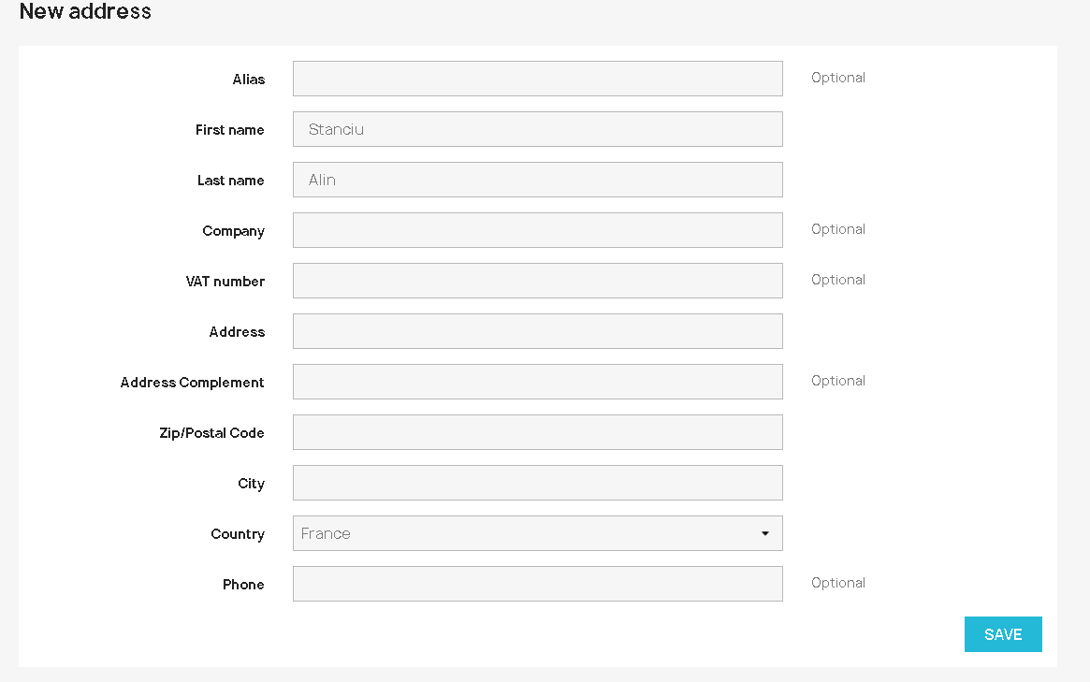New address

|  |  |  |
| --- | --- | --- |
| Test case 1 | **TITLE** | Updating new address with valid values |
| **PRECONDITIONS** | The user is logged in his account  The “new address” page is displayed |
| **STEPS** | The user fills all mandatory fields with valid values  The user clicks on “Save” button |
| **EXPECTED RESULT** | The information is updated and message “Address succsesfully updated.” |
|  |  |  |
| Test case 2 | **TITLE** | Updating new address with empty values |
| **PRECONDITIONS** | The user is logged in his account  The “new address” page is displayed |
| **STEPS** | The user leaves empty all mandatory fields  The user clicks on “Save” button |
| **EXPECTED RESULT** | The information is not updated and message “Please fill out this field.” is displayed in first name field |
|  |  |  |
| Test case 3 | **TITLE** | Updating new address with valid value for first name only |
| **PRECONDITIONS** | The user is logged in his account  The “new address” page is displayed |
| **STEPS** | The user fills first name field with valid value  The user clicks on “Save” button |
| **EXPECTED RESULT** | The information is not updated and message “Please fill out this field.” is displayed in last name field |
|  |  |  |
| Test case 4 | **TITLE** | Updating new address with valid value for last name only |
| **PRECONDITIONS** | The user is logged in his account  The “new address” page is displayed |
| **STEPS** | The user fills last name field with valid value  The user clicks on “Save” button |
| **EXPECTED RESULT** | The information is not updated and message “Please fill out this field.” is displayed in first name field |
|  |  |  |
| Test case 5 | **TITLE** | Updating new address with valid value for address only |
| **PRECONDITIONS** | The user is logged in his account  The “new address” page is displayed |
| **STEPS** | The user fills address field with valid value  The user clicks on “Save” button |
| **EXPECTED RESULT** | The information is not updated and message “Please fill out this field.” is displayed in first name field |
|  |  |  |
| Test case 6 | **TITLE** | Updating new address with valid value for zip/postal code only |
| **PRECONDITIONS** | The user is logged in his account  The “new address” page is displayed |
| **STEPS** | The user fills zip/postal code field with valid value  The user clicks on “Save” button |
| **EXPECTED RESULT** | The information is not updated and message “Please fill out this field.” is displayed in first name field |
|  |  |  |
| Test case 7 | **TITLE** | Updating new address with valid value for city only |
| **PRECONDITIONS** | The user is logged in his account  The “new address” page is displayed |
| **STEPS** | The user fills city field with valid value  The user clicks on “Save” button |
| **EXPECTED RESULT** | The information is not updated and message “Please fill out this field.” is displayed in first name field |
|  |  |  |
| Test case 8 | **TITLE** | Updating new address with valid value for country only |
| **PRECONDITIONS** | The user is logged in his account  The “new address” page is displayed |
| **STEPS** | The user chooses a valid value for country field  The user clicks on “Save” button |
| **EXPECTED RESULT** | The information is not updated and message “Please fill out this field.” is displayed in first name field |
|  |  |  |
| Test case 9 | **TITLE** | Updating new address with valid value for first name and last name only |
| **PRECONDITIONS** | The user is logged in his account  The “new address” page is displayed |
| **STEPS** | The user fills first name and last name fields with valid values  The user clicks on “Save” button |
| **EXPECTED RESULT** | The information is not updated and message “Please fill out this field.” is displayed in address field |
|  |  |  |
| Test case 10 | **TITLE** | Updating new address with valid value for first name and address only |
| **PRECONDITIONS** | The user is logged in his account  The “new address” page is displayed |
| **STEPS** | The user fills first name and address fields with valid values  The user clicks on “Save” button |
| **EXPECTED RESULT** | The information is not updated and message “Please fill out this field.” is displayed in last name field |
|  |  |  |
| Test case 11 | **TITLE** | Updating new address with valid value for first name and zip/postal code only |
| **PRECONDITIONS** | The user is logged in his account  The “new address” page is displayed |
| **STEPS** | The user fills first name and zip/postal code fields with valid values  The user clicks on “Save” button |
| **EXPECTED RESULT** | The information is not updated and message “Please fill out this field.” is displayed in last name field |
|  |  |  |
| Test case 12 | **TITLE** | Updating new address with valid value for first name and city only |
| **PRECONDITIONS** | The user is logged in his account  The “new address” page is displayed |
| **STEPS** | The user fills first name and city fields with valid values  The user clicks on “Save” button |
| **EXPECTED RESULT** | The information is not updated and message “Please fill out this field.” is displayed in last name field |
|  |  |  |
| Test case 13 | **TITLE** | Updating new address with valid value for first name and country only |
| **PRECONDITIONS** | The user is logged in his account  The “new address” page is displayed |
| **STEPS** | The user fills first name and country fields with valid values  The user clicks on “Save” button |
| **EXPECTED RESULT** | The information is not updated and message “Please fill out this field.” is displayed in last name field |
|  |  |  |
| Test case 14 | **TITLE** | Updating new address with valid value for last name and address only |
| **PRECONDITIONS** | The user is logged in his account  The “new address” page is displayed |
| **STEPS** | The user fills last name and address fields with valid values  The user clicks on “Save” button |
| **EXPECTED RESULT** | The information is not updated and message “Please fill out this field.” is displayed in first name field |
|  |  |  |
| Test case 15 | **TITLE** | Updating new address with valid value for address and zip/postal code only |
| **PRECONDITIONS** | The user is logged in his account  The “new address” page is displayed |
| **STEPS** | The user fills address and zip/postal code fields with valid values  The user clicks on “Save” button |
| **EXPECTED RESULT** | The information is not updated and message “Please fill out this field.” is displayed in first name field |
|  |  |  |
| Test case 16 | **TITLE** | Updating new address with valid value for address and city only |
| **PRECONDITIONS** | The user is logged in his account  The “new address” page is displayed |
| **STEPS** | The user fills address and city fields with valid values  The user clicks on “Save” button |
| **EXPECTED RESULT** | The information is not updated and message “Please fill out this field.” is displayed in first name field |
|  |  |  |
| Test case 17 | **TITLE** | Updating new address with valid value for address and country only |
| **PRECONDITIONS** | The user is logged in his account  The “new address” page is displayed |
| **STEPS** | The user fills address and country fields with valid values  The user clicks on “Save” button |
| **EXPECTED RESULT** | The information is not updated and message “Please fill out this field.” is displayed in first name field |
|  |  |  |
| Test case 17 | **TITLE** | Updating new address with valid value for zip/postal code and city only |
| **PRECONDITIONS** | The user is logged in his account  The “new address” page is displayed |
| **STEPS** | The user fills zip/postal code and city fields with valid values  The user clicks on “Save” button |
| **EXPECTED RESULT** | The information is not updated and message “Please fill out this field.” is displayed in first name field |
|  |  |  |
| Test case 18 | **TITLE** | Updating new address with valid value for zip/postal code and country only |
| **PRECONDITIONS** | The user is logged in his account  The “new address” page is displayed |
| **STEPS** | The user fills zip/postal code and country fields with valid values  The user clicks on “Save” button |
| **EXPECTED RESULT** | The information is not updated and message “Please fill out this field.” is displayed in first name field |
|  |  |  |
| Test case 19 | **TITLE** | Updating new address with valid value for zip/postal code and city only |
| **PRECONDITIONS** | The user is logged in his account  The “new address” page is displayed |
| **STEPS** | The user fills zip/postal code and city fields with valid values  The user clicks on “Save” button |
| **EXPECTED RESULT** | The information is not updated and message “Please fill out this field.” is displayed in first name field |
|  |  |  |
| Test case 20 | **TITLE** | Updating new address with valid values for first name,last name and address only |
| **PRECONDITIONS** | The user is logged in his account  The “new address” page is displayed |
| **STEPS** | The user fills first name, last name and address fields with valid values  The user clicks on “Save” button |
| **EXPECTED RESULT** | The information is not updated and message “Please fill out this field.” is displayed in zip/postal code field |
|  |  |  |
| Test case 21 | **TITLE** | Updating new address with valid values for first name,last name and zip/postal code only |
| **PRECONDITIONS** | The user is logged in his account  The “new address” page is displayed |
| **STEPS** | The user fills first name, last name and zip/postal code fields with valid values  The user clicks on “Save” button |
| **EXPECTED RESULT** | The information is not updated and message “Please fill out this field.” is displayed in city field |
|  |  |  |
| Test case 22 | **TITLE** | Updating new address with valid values for first name,last name and city only |
| **PRECONDITIONS** | The user is logged in his account  The “new address” page is displayed |
| **STEPS** | The user fills first name, last name and city fields with valid values  The user clicks on “Save” button |
| **EXPECTED RESULT** | The information is not updated and message “Please fill out this field.” is displayed in address field |
|  |  |  |
| Test case 23 | **TITLE** | Updating new address with valid values for first name,last name and country only |
| **PRECONDITIONS** | The user is logged in his account  The “new address” page is displayed |
| **STEPS** | The user fills first name, last name and country fields with valid values  The user clicks on “Save” button |
| **EXPECTED RESULT** | The information is not updated and message “Please fill out this field.” is displayed in address field |
|  |  |  |
| Test case 24 | **TITLE** | Updating new address with valid values for first name,last name, address and zip/postal code only |
| **PRECONDITIONS** | The user is logged in his account  The “new address” page is displayed |
| **STEPS** | The user fills first name, last name, address and zip/postal code fields with valid values  The user clicks on “Save” button |
| **EXPECTED RESULT** | The information is not updated and message “Please fill out this field.” is displayed in city field |
|  |  |  |
| Test case 25 | **TITLE** | Updating new address with valid values for first name,last name, address and city only |
| **PRECONDITIONS** | The user is logged in his account  The “new address” page is displayed |
| **STEPS** | The user fills first name, last name, address and city fields with valid values  The user clicks on “Save” button |
| **EXPECTED RESULT** | The information is not updated and message “Please fill out this field.” is displayed in zip/postal code field |
|  |  |  |
| Test case 26 | **TITLE** | Updating new address with valid values for first name,last name address and country only |
| **PRECONDITIONS** | The user is logged in his account  The “new address” page is displayed |
| **STEPS** | The user fills first name, last name, address and country fields with valid values  The user clicks on “Save” button |
| **EXPECTED RESULT** | The information is not updated and message “Please fill out this field.” is displayed in zip/postal code field |
|  |  |  |
| Test case 27 | **TITLE** | Updating new address with valid values for first name,last name,address,zip/postal code only |
| **PRECONDITIONS** | The user is logged in his account  The “new address” page is displayed |
| **STEPS** | The user fills first name, last name, address ,zip/postal and city code fields with valid values  The user clicks on “Save” button |
| **EXPECTED RESULT** | The information is not updated and message “Please fill out this field.” is displayed in country field |
|  |  |  |
| Test case 28 | **TITLE** | Updating new address with invalid first name |
| **PRECONDITIONS** | The user is logged in his account  The “new address” page is displayed |
| **STEPS** | The user fills first name with invalid values and valid values for all the rest of mandatory fields  The user clicks on “Save” button |
| **EXPECTED RESULT** | The information is not updated and message “Please fix error below.” and “Invalid name” message is displayed |
|  |  |  |
| Test case 28 | **TITLE** | Updating new address with invalid last name |
| **PRECONDITIONS** | The user is logged in his account  The “new address” page is displayed |
| **STEPS** | The user fills last name with invalid values and valid values for all the rest of mandatory fields  The user clicks on “Save” button |
| **EXPECTED RESULT** | The information is not updated and message “Please fix error below.” and “Invalid name” message is displayed |
|  |  |  |
| Test case 29 | **TITLE** | Updating new address with invalid zip/postal code |
| **PRECONDITIONS** | The user is logged in his account  The “new address” page is displayed |
| **STEPS** | The user fills zip/postal code with invalid values and valid values for the rest of mandatory fields  The user clicks on “Save” button |
| **EXPECTED RESULT** | The information is not updated and message “Invalid postcode – should be look like ‘NNNNN’” is displayed |
|  |  |  |
| Test case 30 | **TITLE** | Updating new address with invalid address |
| **PRECONDITIONS** | The user is logged in his account  The “new address” page is displayed |
| **STEPS** | The user fills address field with invalid value and the rest of the mandatory fields with valid values  The user clicks on “Save” button |
| **EXPECTED RESULT** | The information is not updated and message “Invalid format” is displayed |
|  |  |  |
| **BUG**  Test case  31 | **TITLE** | Updating new address with invalid city |
| **PRECONDITIONS** | The user is logged in his account  The “new address” page is displayed |
| **STEPS** | The user fills the city field with invalid values and valid values for the rest of mandatory fields  The user clicks on “Save” button |
| **EXPECTED RESULT** | The information is not updated and message “Please fix error below.” and “Invalid city” message is displayed |
|  | **ACTUAL RESULT** | Information is updated. |

* 1. 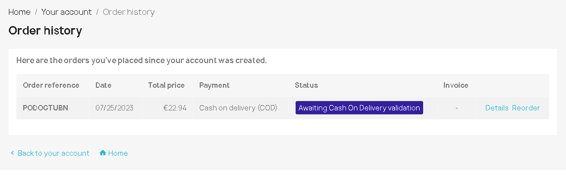Order history

|  |  |  |
| --- | --- | --- |
| Test case 1 | **TITLE** | Details button in order history page |
| **PRECONDITIONS** | The user is logged in his account and made a product checkout  The “order history” page is displayed |
| **STEPS** | The user clicks on “Details” button |
| **EXPECTED RESULT** | A new page with the name “Order details” is displayed |
|  |  |  |
| Test case  2 | **TITLE** | Reorder button in order history page |
| **PRECONDITIONS** | The user is logged in his account and made a product checkout  The “order history” page is displayed |
| **STEPS** | The user clicks on “Reorder” button |
| **EXPECTED RESULT** | A new page is displayed where user can reorder the product |
|  |  |  |
| **BUG**  Test case 3 | **TITLE** | Adding message to order with invalid product selected |
| **PRECONDITIONS** | The user is logged in his account and made a product checkout  The “order history” page is displayed |
| **STEPS** | The user clicks on “Details” button  The user scrolls down to “add message” section  The user enters a message in textbox then clicks “Send” |
| **EXPECTED RESULT** | The update should not be done due to not choosing product |
|  | **ACTUAL RESULT** | Information is updated and message “Message successfully sent” is displayed |
| Test case 4 | **TITLE** | Adding message to order with valid product |
| **PRECONDITIONS** | The user is logged in his account and made a product checkout  The “order history” page is displayed |
| **STEPS** | The user clicks on “Details” button  The user scrolls down to “add message” section  The user selects a product  The user enters a message in textbox then clicks “Send” |
| **EXPECTED RESULT** | Information is updated and message “Message succsessfully sent” is displayed |
|  |  |  |
| Test case 5 | **TITLE** | Adding empty message to order |
| **PRECONDITIONS** | The user is logged in his account and made a product checkout  The “order history” page is displayed |
| **STEPS** | The user clicks on “Details” button  The user scrolls down to “add message” section  The user clicks “Send” |
| **EXPECTED RESULT** | Information is not updated and message “The message cannot be blank.” is displayed |

* 1. 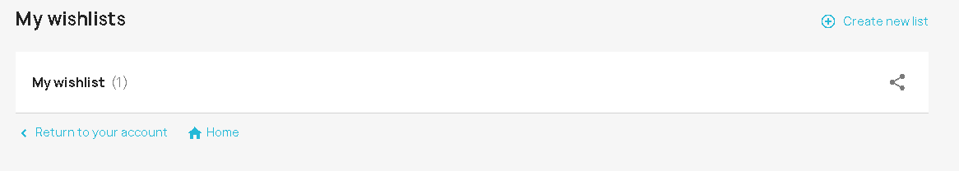My wishlists

|  |  |  |
| --- | --- | --- |
| Test case 1 | **TITLE** | Creating new list button |
| **PRECONDITIONS** | The user is logged in his account  The “My wishlists” page is displayed |
| **STEPS** | The user clicks on “Create new list” button |
| **EXPECTED RESULT** | A form is displayed where user can name a new wishlist |
|  |  |  |
| Test case 2 | **TITLE** | Creating new wishlist |
| **PRECONDITIONS** | The user is logged in his account  The “My wishlists” page is displayed  The user clicks on “Create new list” button |
| **STEPS** | The user enters a name for the wishlist  The user clicks on “Create wishlist” |
| **EXPECTED RESULT** | A new wishlist is created and displayed |
|  |  |  |
| Test case 3 | **TITLE** | Renaming wishlist button |
| **PRECONDITIONS** | The user is logged in his account  The “My wishlists” page is displayed  The user has created a wishlist |
| **STEPS** | The user clicks on “Rename”. |
| **EXPECTED RESULT** | A form is displayed where user can rename the wishlist |
|  |  |  |
| Test case 3 | **TITLE** | Renaming wishlist |
| **PRECONDITIONS** | The user is logged in his account  The “My wishlists” page is displayed  The user has created a wishlist  The user clicks on “Rename”. |
| **STEPS** | The user enters a value for wishlist name  The user clicks on “Rename wishlist” |
| **EXPECTED RESULT** | The wishlist name is updated and message “List has been renamed” is displayed |
|  |  |  |
| Test case 5 | **TITLE** | Sharing wishlist button |
| **PRECONDITIONS** | The user is logged in his account  The “My wishlists” page is displayed  The user has created a wishlist |
| **STEPS** | The user clicks on “Share” button |
| **EXPECTED RESULT** | A form is displayed where user can share the link of wishlist |
|  |  |  |
| Test case 6 | **TITLE** | Sharing wishlist |
| **PRECONDITIONS** | The user is logged in his account  The “My wishlists” page is displayed  The user has created a wishlist  The user clicks on “Share” button |
| **STEPS** | The user clicks on “Copy text” button |
| **EXPECTED RESULT** | The link from wishlist is copied and message “Share link copied!” is displayed |
|  |  |  |
| Test case 7 | **TITLE** | Delete wishlist button |
| **PRECONDITIONS** | The user is logged in his account  The “My wishlists” page is displayed  The user has created a wishlist |
| **STEPS** | The user clicks on trash bin icon |
| **EXPECTED RESULT** | A form is displayed where user can delete the wishlist |
|  |  |  |
| Test case 8 | **TITLE** | Deleting wishlist |
| **PRECONDITIONS** | The user is logged in his account  The “My wishlists” page is displayed  The user has created a wishlist  The user clicks on trash bin icon |
| **STEPS** | The user clicks on “Delete” button |
| **EXPECTED RESULT** | The wishlist is deleted and message “List has been removed” is displayed |
|  |  |  |
| Test case 7 | **TITLE** | Viewing the wishlist |
| **PRECONDITIONS** | The user is logged in his account  The “My wishlists” page is displayed  The user has created a wishlist |
| **STEPS** | The user clicks on wishlist |
| **EXPECTED RESULT** | The products from wishlist are being shown |
|  |  |  |
| Test case 8 | **TITLE** | Adding to cart item from wishlist |
| **PRECONDITIONS** | The user is logged in his account  The “My wishlists” page is displayed  The user has created a wishlist  The user clicks on “Share” button |
| **STEPS** | The user clicks on “Copy text” button |
| **EXPECTED RESULT** | The link from wishlist is copied and message “Share link copied!” is displayed |
|  |  |  |
| Test case 9 | **TITLE** | Sorting the wishlist by name Z to A |
| **PRECONDITIONS** | The user is logged in his account  The “My wishlists” page is displayed  The user has created a wishlist with more products  The user clicks on wishlist |
| **STEPS** | The user clicks on “Sort by” button and selects “Name Z to A” |
| **EXPECTED RESULT** | The wishlist is sorted by selected order |
|  |  |  |
| Test case 10 | **TITLE** | Sorting the wishlist by name A to Z |
| **PRECONDITIONS** | The user is logged in his account  The “My wishlists” page is displayed  The user has created a wishlist with more products  The user clicks on wishlist |
| **STEPS** | The user clicks on “Sort by” button and selects “Name A to Z” |
| **EXPECTED RESULT** | The wishlist is sorted by selected order |
|  |  |  |
| Test case 11 | **TITLE** | Sorting the wishlist by relevance |
| **PRECONDITIONS** | The user is logged in his account  The “My wishlists” page is displayed  The user has created a wishlist with more products  The user clicks on wishlist |
| **STEPS** | The user clicks on “Sort by” button and selects “relevance” |
| **EXPECTED RESULT** | The wishlist is sorted by selected order |
|  |  |  |
| Test case 12 | **TITLE** | Sorting the wishlist by price,low to high |
| **PRECONDITIONS** | The user is logged in his account  The “My wishlists” page is displayed  The user has created a wishlist with more products  The user clicks on wishlist |
| **STEPS** | The user clicks on “Sort by” button and selects “price, low to high” |
| **EXPECTED RESULT** | The wishlist is sorted by selected order |
|  |  |  |
| Test case 12 | **TITLE** | Sorting the wishlist by price,high to low |
| **PRECONDITIONS** | The user is logged in his account  The “My wishlists” page is displayed  The user has created a wishlist with more products  The user clicks on wishlist |
| **STEPS** | The user clicks on “Sort by” button and selects “price, high to low” |
| **EXPECTED RESULT** | The wishlist is sorted by selected order |

* 1. 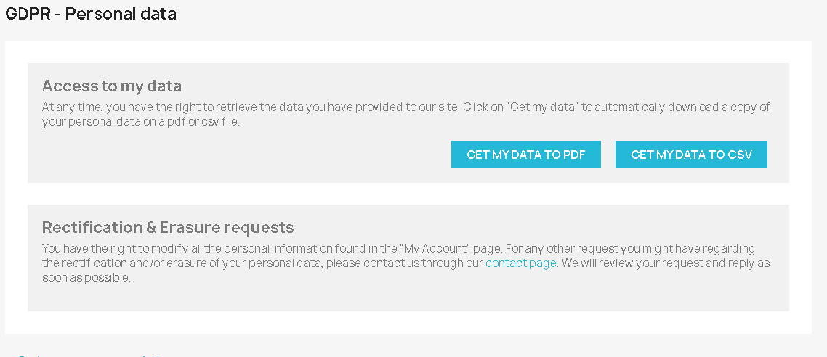GDPR – PERSONAL DATA

|  |  |  |
| --- | --- | --- |
| Test case 1 | **TITLE** | Getting data to pdf |
| **PRECONDITIONS** | The user is logged in his account  The “GDPR – Personal data” page is displayed |
| **STEPS** | The user clicks on “Get my data to pdf” button |
| **EXPECTED RESULT** | The user gets to download GDPR data in .pdf format |
|  |  |  |
| Test case 2 | **TITLE** | Getting data to csv |
| **PRECONDITIONS** | The user is logged in his account  The “GDPR – Personal data” page is displayed |
| **STEPS** | The user clicks on “Get my data to csv” button |
| **EXPECTED RESULT** | The user gets to download GDPR data in .word format |

1. Product page

|  |  |  |
| --- | --- | --- |
| Test case 1 | **TITLE** | Adding a product to cart |
| **PRECONDITIONS** | The user is logged in his account  The product page is displayed |
| **STEPS** | The user clicks on “Add to cart” button |
| **EXPECTED RESULT** | The product is added to cart |
|  |  |  |
| Test case 2 | **TITLE** | Adding another product to cart |
| **PRECONDITIONS** | The user is logged in his account  The product page is displayed |
| **STEPS** | The user clicks on “Add to cart” button |
| **EXPECTED RESULT** | The product is added to cart |
|  |  |  |
| Test case 3 | **TITLE** | Adding product with different item type to cart |
| **PRECONDITIONS** | The user is logged in his account  The product page is displayed |
| **STEPS** | The user clicks on product type  The user chooses another product type  The user clicks on “Add to cart” button |
| **EXPECTED RESULT** | The product is added to cart with specified type |
|  |  |  |
| Test case 4 | **TITLE** | Editing quantity of a product and adding to cart |
| **PRECONDITIONS** | The user is logged in his account  The product page is displayed |
| **STEPS** | The user clicks on upside arrow where quantity is located  The user clicks on “Add to cart” button |
| **EXPECTED RESULT** | The product is added to cart with specified quantity |
|  |  |  |
| Test case 5 | **TITLE** | Sharing product to facebook |
| **PRECONDITIONS** | The user is logged in his account  The product page is displayed |
| **STEPS** | The user clicks on facebook icon |
| **EXPECTED RESULT** | A new page is displayed where user can share to facebook the product |
|  |  |  |
| Test case 6 | **TITLE** | Sharing product to twitter |
| **PRECONDITIONS** | The user is logged in his account  The product page is displayed |
| **STEPS** | The user clicks on twitter icon |
| **EXPECTED RESULT** | A new page is displayed where user can share to twitter the product |
|  |  |  |
| Test case 7 | **TITLE** | Sharing product to pinterest |
| **PRECONDITIONS** | The user is logged in his account  The product page is displayed |
| **STEPS** | The user clicks on pinterest icon |
| **EXPECTED RESULT** | A new page is displayed where user can share to twitter the product |
|  |  |  |
| Test case 8 | **TITLE** | Review of a product |
| **PRECONDITIONS** | The user is logged in his account  The product page is displayed |
| **STEPS** | The user clicks on “Write your review” button |
| **EXPECTED RESULT** | A form is displayed where user can write a review about a product |
|  |  |  |
| Test case 9 | **TITLE** | Writing a review of a product |
| **PRECONDITIONS** | The user is logged in his account  The product page is displayed  The user clicks on “Write your review” button |
| **STEPS** | The user fills mandatory fields  The user clicks on “Send” button |
| **EXPECTED RESULT** | The review is sent to be approved by a moderator |

1. 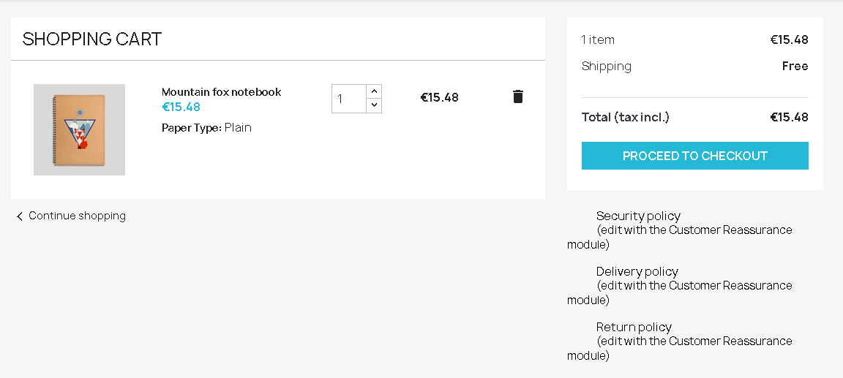Proceeding to checkout

|  |  |  |
| --- | --- | --- |
| Test case 1 | **TITLE** | Proceeding to checkout |
| **PRECONDITIONS** | The user is logged in his account  The user has at least one item in shopping cart  The shopping cart page is displayed |
| **STEPS** | The user clicks on proceed to checkout |
| **EXPECTED RESULT** | Addresses page is displayed. |
|  |  |  |
| Test case 2 | **TITLE** | Proceeding to checkout through addresses |
| **PRECONDITIONS** | The user is logged in his account  The user has at least one item in shopping cart  The user proceeds to checkout  The addresses page is displayed |
| **STEPS** | The user selects an address  The user clicks “Continue” |
| **EXPECTED RESULT** | Shopping method page is displayed |
|  |  |  |
| Test case 3 | **TITLE** | Proceeding to checkout through shipping method |
| **PRECONDITIONS** | The user is logged in his account  The user has at least one item in shopping cart  The user proceds to checkout  The user proceeds through addresses  The user proceeds to shipping method |
| **STEPS** | The user selects the preferred shipping method  The user clicks on “Continue” |
| **EXPECTED RESULT** | Shopping method page is displayed |
|  |  |  |
| Test case 4 | **TITLE** | Proceeding to checkout through payment |
| **PRECONDITIONS** | The user is logged in his account  The user has at least one item in shopping cart  The user proceds to checkout  The user proceeds through addresses  The user proceeds through shipping method  The user proceeds to payment |
| **STEPS** | The user selects the preferred payment method  The user ticks the checkbox  The user clicks on “Place order” button |
| **EXPECTED RESULT** | The order is placed and the message “Your order is confirmed “ is displayed |